**LAPORAN TUGAS**

**PEMROGRAMAN WEB**

**PEKAN 2**



**DISUSUN OLEH:**

|  |  |
| --- | --- |
| **NIM** | **L200220277** |
| **NAMA** | **MHD. FARHAN LUBIS** |
| **KELAS** | **D** |

**PROGRAM STUDI INFORMATIKA**

**FAKULTAS KOMUNIKASI DAN INFORMATIKA**

**UNIVERSITAS MUHAMMADIYAH SURAKARTA**

**2023**

# **DAFTAR ISI**

**DAFTAR ISI** 2

**1)** **Halaman utama profil data (data-profile.html)** 3

**a)** **Kode** 3

**b)** **Hasil** 4

**2)** **Halaman kesibukan (activities.html)** 5

**a)** **Kode** 5

**b)** **Hasil** 6

**3)** **Halaman hobi (hobbies.html)** 7

**a)** **Kode** 7

**b)** **Hasil** 8

# **Halaman utama profil data (data-profile.html)**

## **Kode**

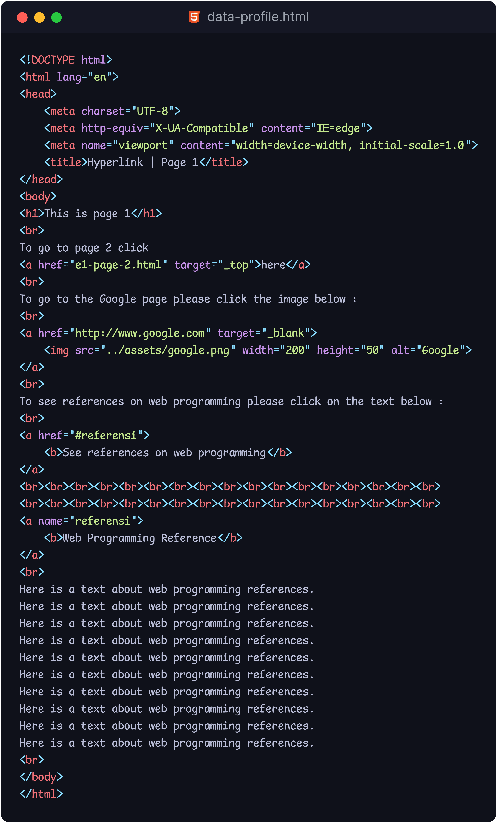

## **Hasil**

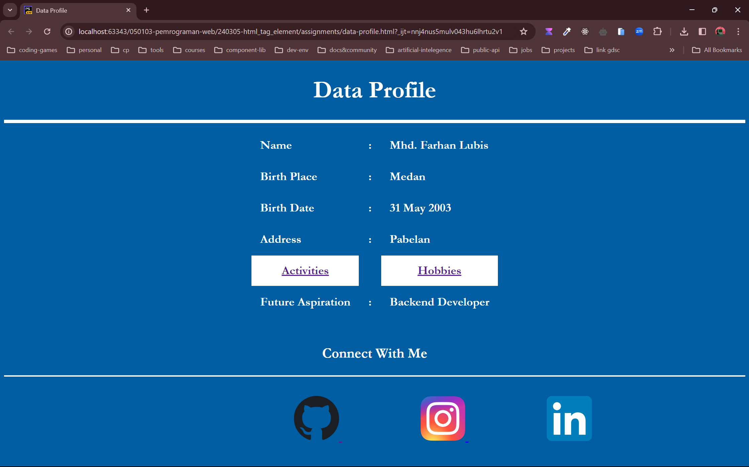

# **Halaman kesibukan (activities.html)**

## **Kode**

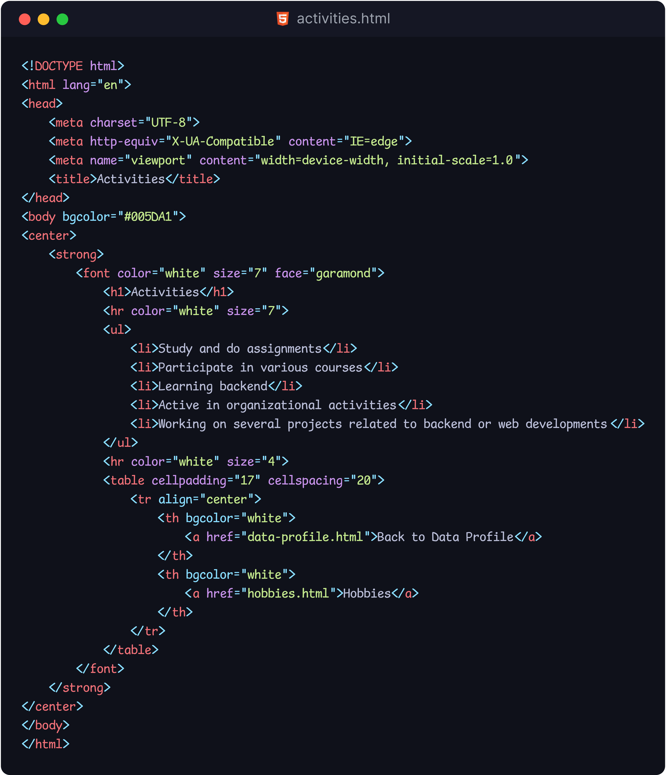

## **Hasil**

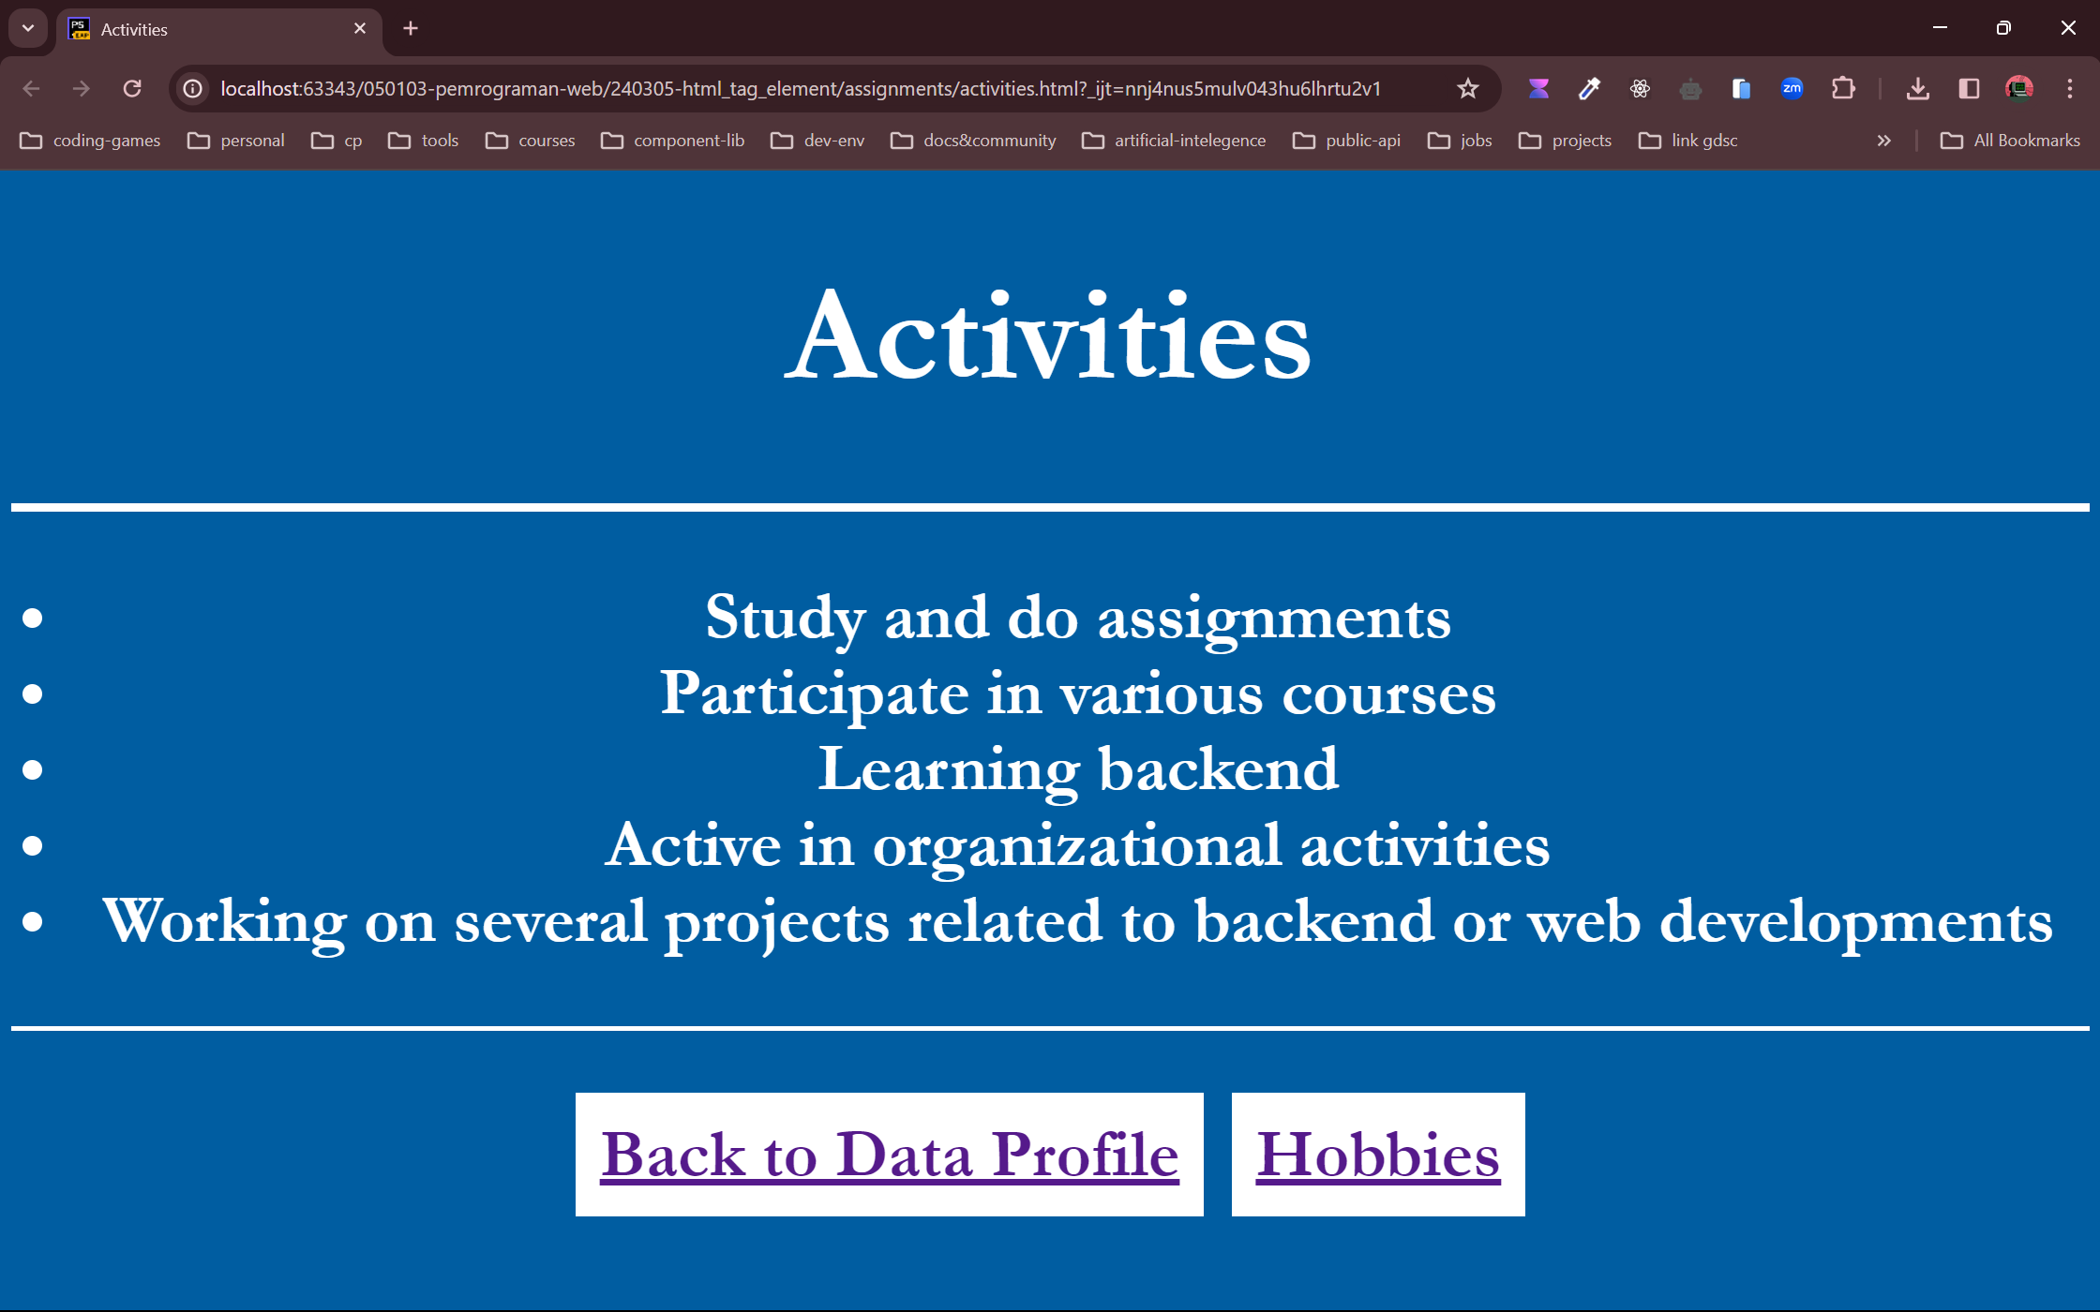

# **Halaman hobi (hobbies.html)**

## **Kode**

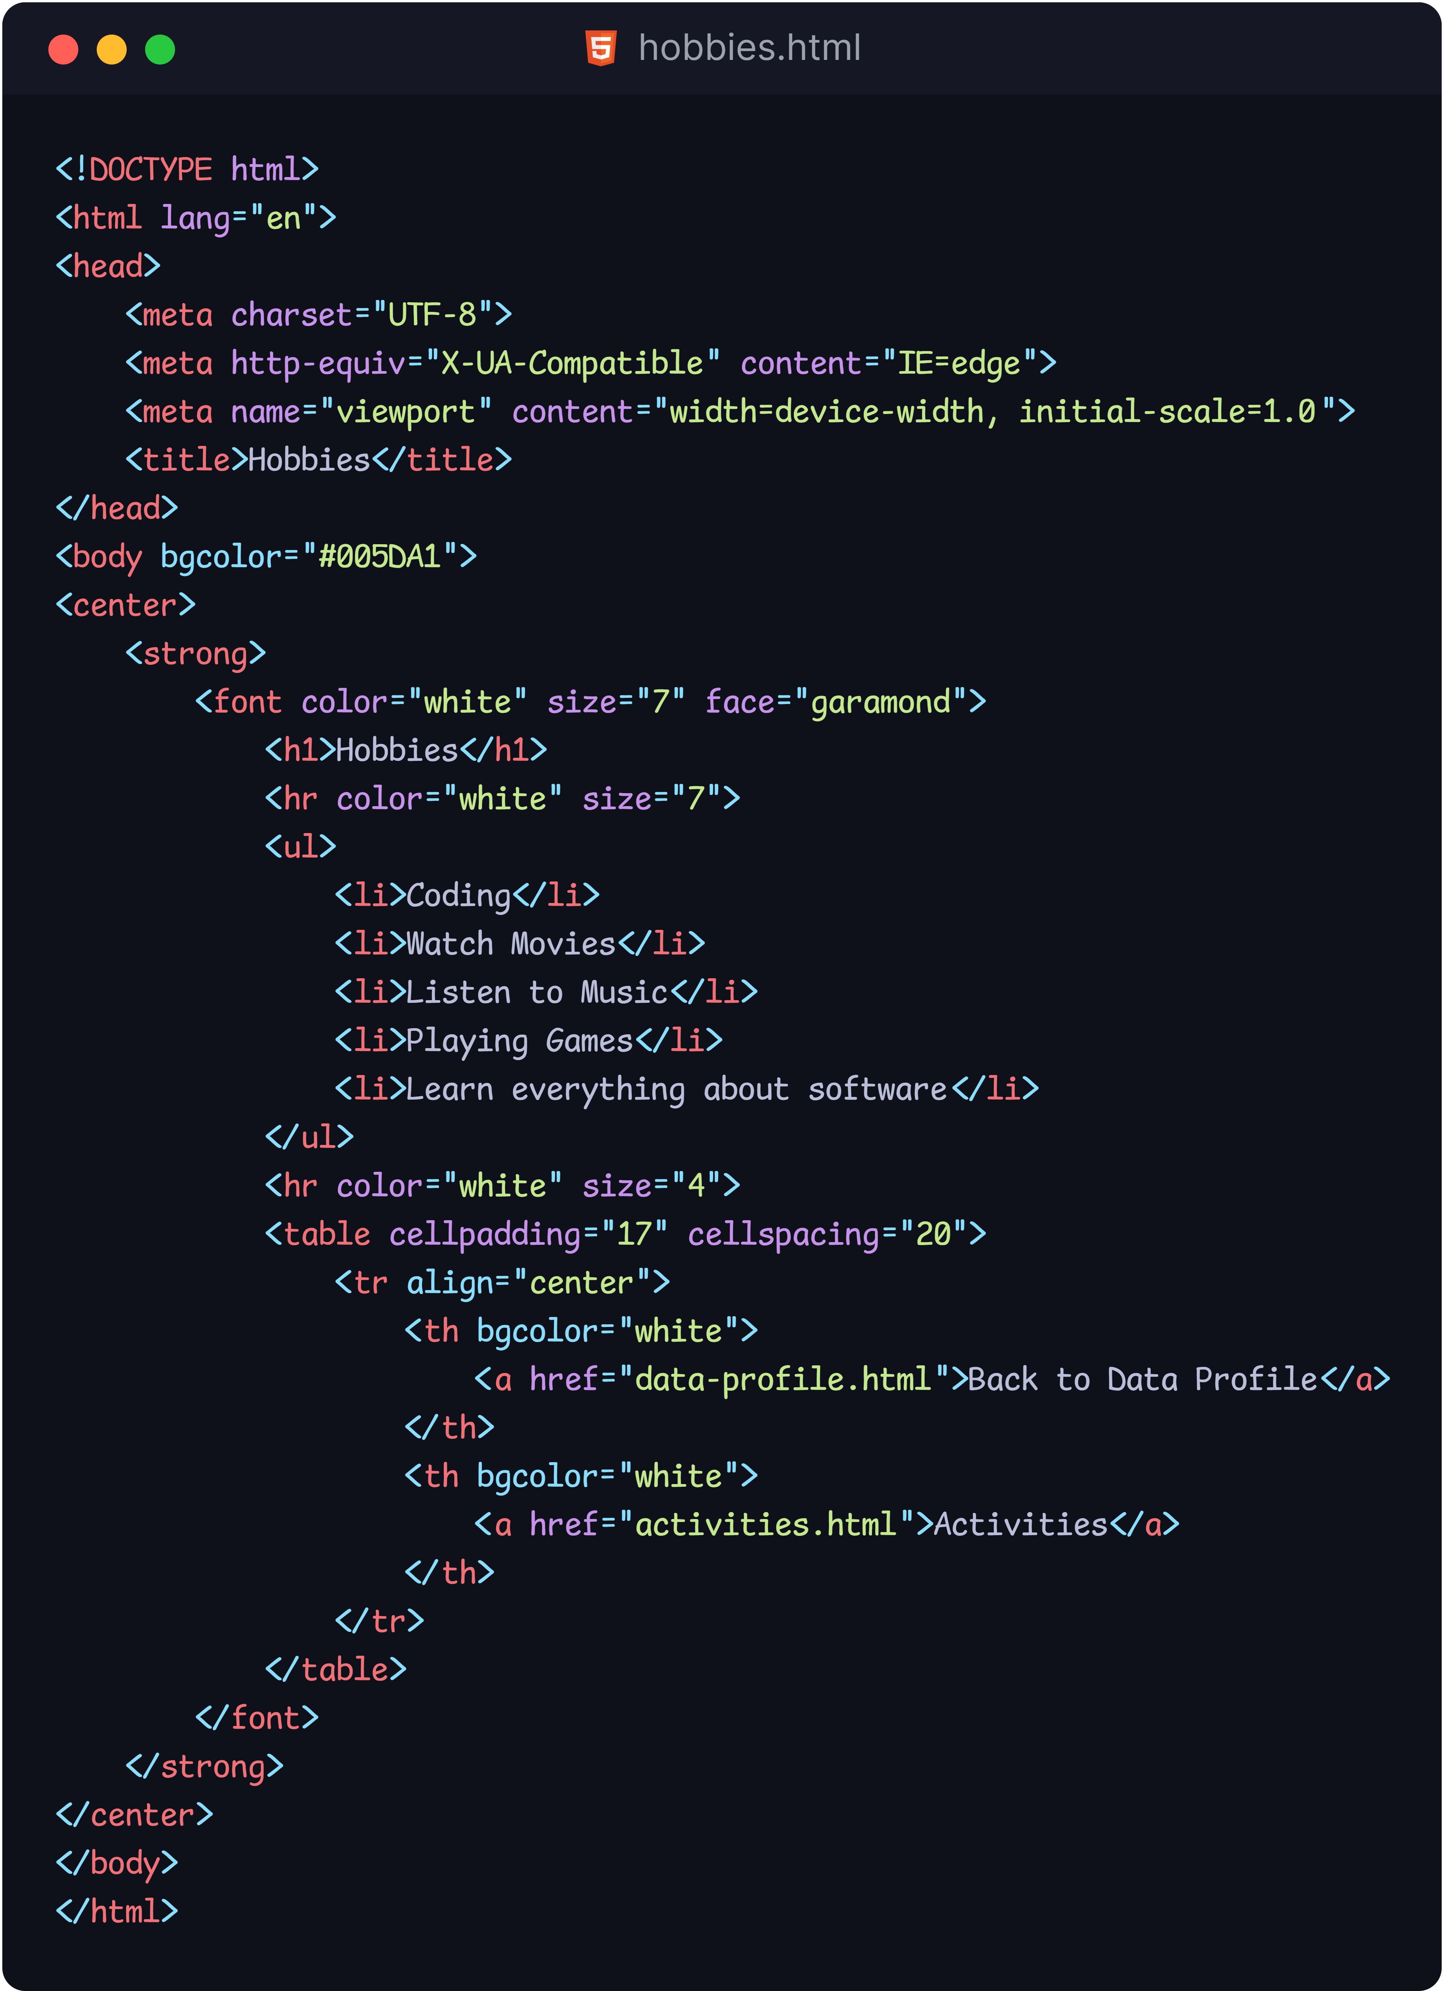

## **Hasil**

